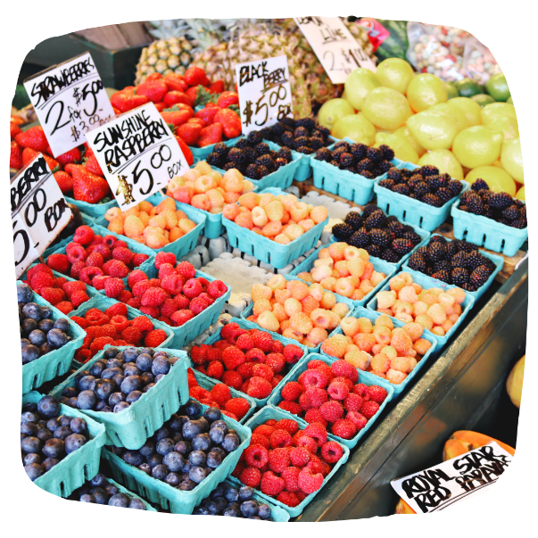
MARKET MATCH AT FARMERS MARKETS FACT SHEET
YOUR LOGO HERE
Market Match is a program for people on CalFresh (formerly known as Food Stamps) to help them buy healthy food at participating farmers markets. For every dollar of CalFresh benefits, the program gives an extra $1 in Market Match tokens or vouchers that can be used to buy fruits and vegetables. Most farmers markets match up to $10, while supplies last.
Who is eligible for Market Match?
You must be participating in CalFresh to use Market Match. Call 1-866-613-3777 or visit GetCalFresh.org to apply for CalFresh.
How do I apply for Market Match?
There is no application required to use Market Match. Simply follow the steps below to use your Market Match benefit:

Visit marketmatch.org for questions and
more information about Market Match.

